Delphi Development Guide

This Demo is developed based on Delphi 10.3.
1.dll interface method reference. as Figure 1-1：
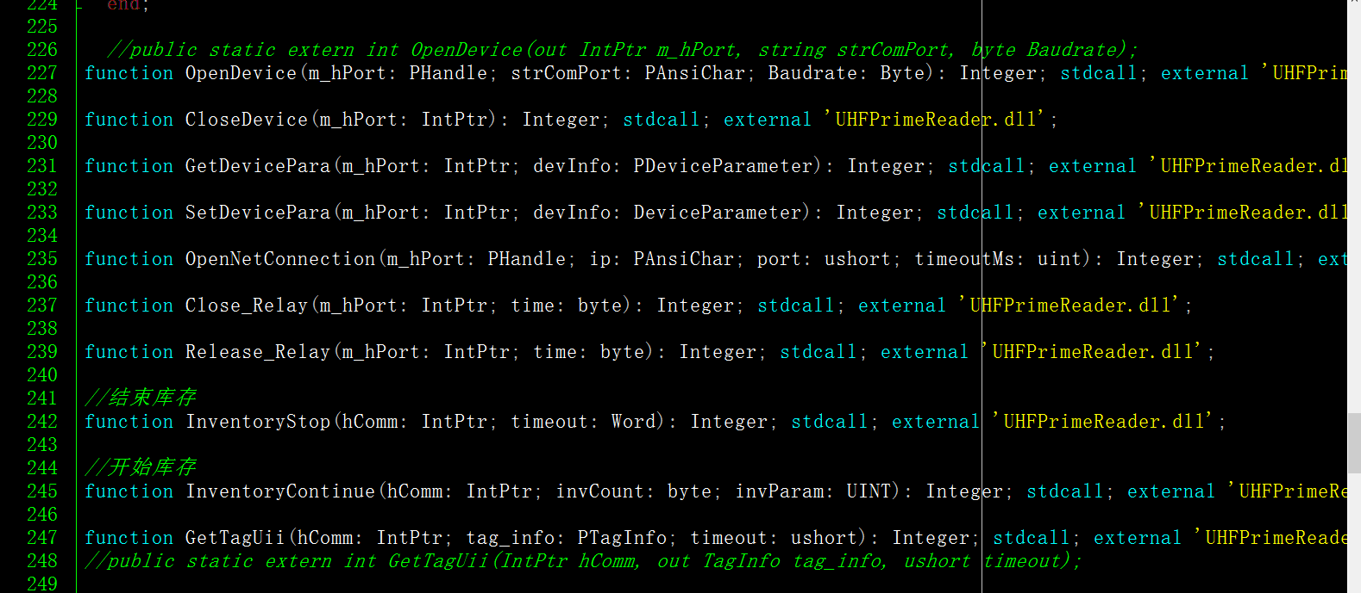
Figure 1-1
2.DLL calling method, as Figure 1-2
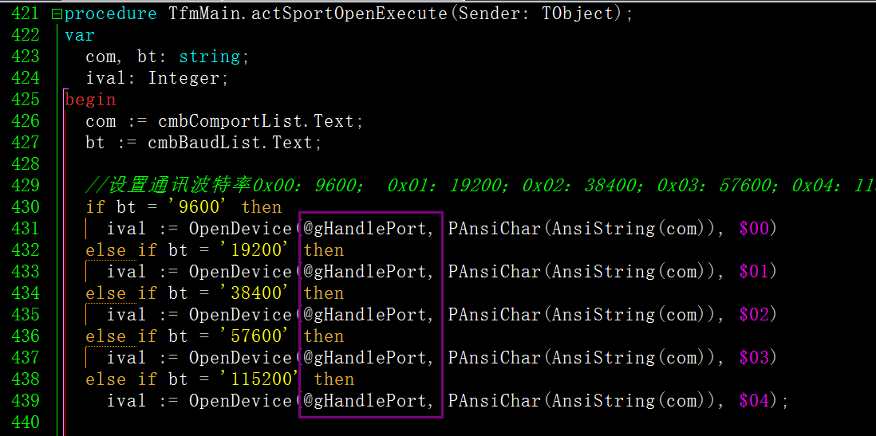
Figure 1-2
3.For details, please refer to. \Sample\delphi\testdemo source code:UHFPrimeReader.dpr, UHFPrimeReader.dproj

